Householder transformation

function: Euclidean Norm Calculation for Vectors

Purpose: This function calculates the Euclidean norm (magnitude) of a vector v of length len.
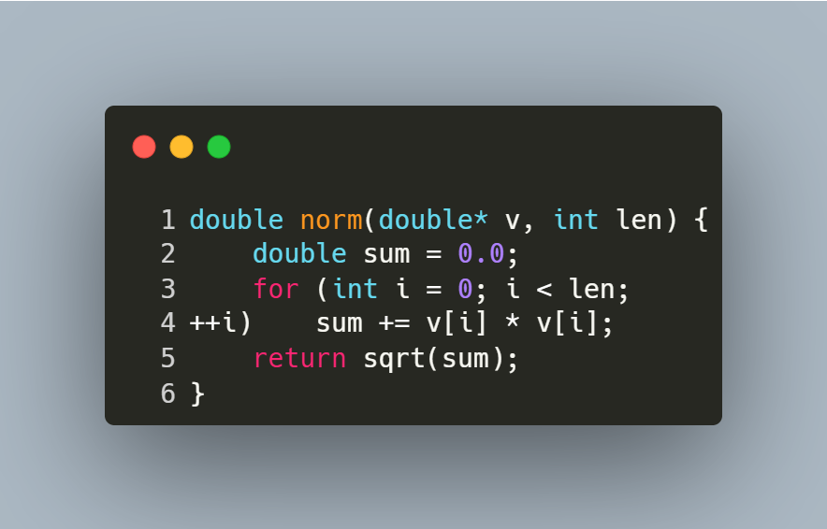
Step-by-Step Explanation
- Initialization:
  - double sum = 0.0; initializes a variable to accumulate the sum of squared elements.
- Loop Through Elements:
  - for (int i = 0; i < len; ++i) iterates over each element of the vector.
- Sum of Squares:
  - sum += v[i] * v[i]; squares each element and adds it to sum.
- Final Calculation:
  - return sqrt(sum); returns the square root of the accumulated sum, giving the Euclidean norm.

function: Matrix Multiplication for Square Matrices

Purpose: This function multiplies two square matrices A and B of size n x n and stores the result in matrix C.
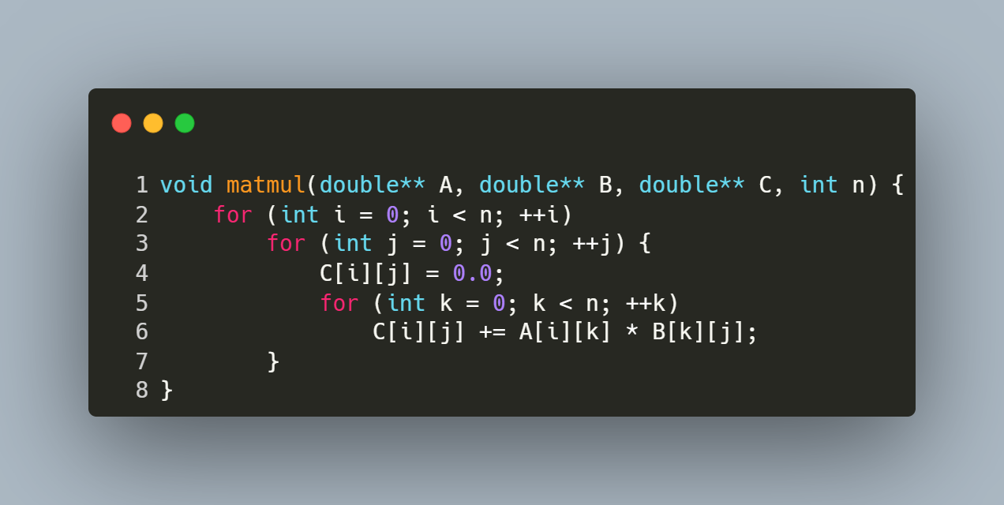
Step-by-Step Explanation
- Row Iteration (i loop):
  - Iterates over each row of matrix A (from 0 to n-1).
- Column Iteration (j loop):
  - For each row i, iterates over each column of matrix B (from 0 to n-1).
- Element Initialization:
  - C[i][j] = 0.0; resets the target element in C to zero to avoid garbage values.
- Dot Product Calculation (k loop):
  - Computes the dot product of the i-th row of A and the j-th column of B.
  - Accumulates the sum of products: C[i][j] += A[i][k] * B[k][j];.
- Result Storage:
  - After the k loop completes, C[i][j] holds the final value for the element at row i, column j of the product matrix.

function: Matrix Transposition

Purpose: This function computes the transpose of a square matrix src of size n x n and stores the result in another matrix dst.
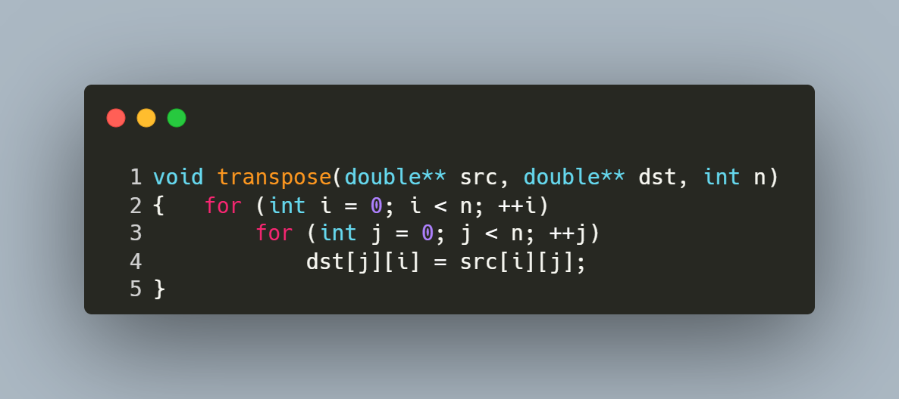
Step-by-Step Explanation
- Outer Loop (i loop):
  - Iterates over each row of the source matrix src (from 0 to n-1).
- Inner Loop (j loop):
  - For each row i, iterates over each column of the source matrix src (from 0 to n-1).
- Transpose Operation:
  - The element at position (i, j) in the source matrix is assigned to position (j, i) in the destination matrix:
    - dst[j][i] = src[i][j];.
- Result Storage:
  - After all iterations, the destination matrix dst contains the transpose of the source matrix src.

function: QR Factorization Using Householder Reflections

Purpose: This function performs QR decomposition of a square matrix A into an orthogonal matrix Q and an upper triangular matrix R using Householder reflections.

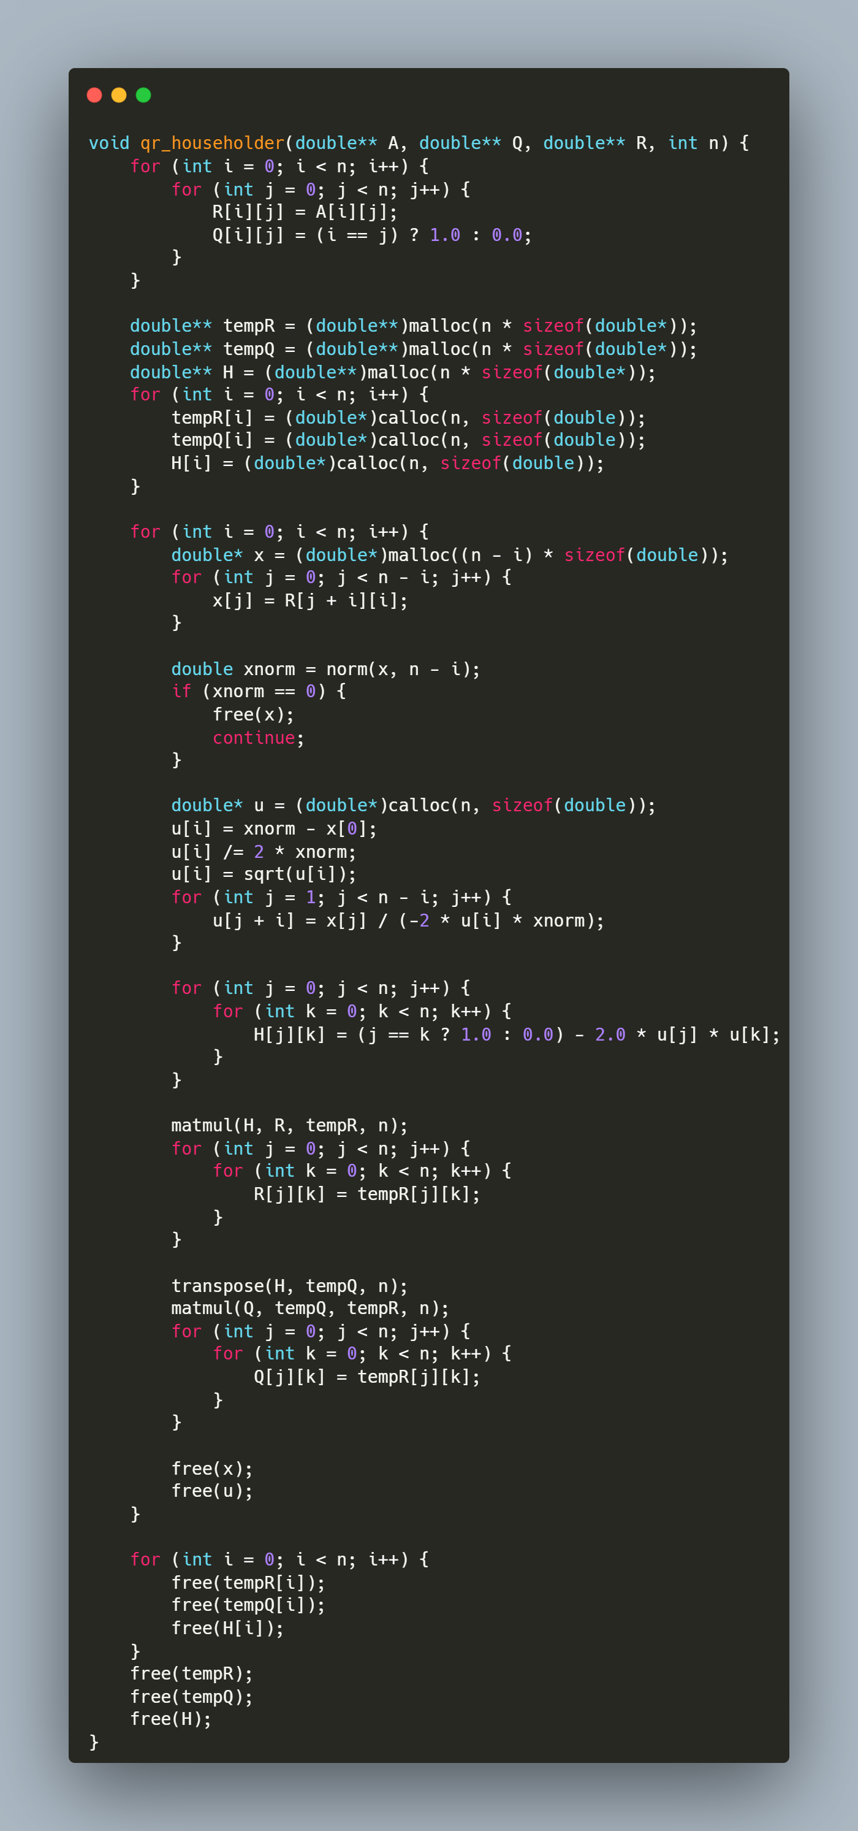
Step-by-Step Explanation
1. Initialization
for (int i = 0; i < n; i++) {
for (int j = 0; j < n; j++) {
R[i][j] = A[i][j];
Q[i][j] = (i == j) ? 1.0 : 0.0;
}
}
- R is initialized as a copy of A.
- Q starts as an identity matrix, which will accumulate orthogonal transformations.
2. Temporary Matrix Allocation
double** tempR = (double**)malloc(n * sizeof(double*));
double** tempQ = (double**)malloc(n * sizeof(double*));
double** H = (double**)malloc(n * sizeof(double*));
for (int i = 0; i < n; i++) {
tempR[i] = (double*)calloc(n, sizeof(double));
tempQ[i] = (double*)calloc(n, sizeof(double));
H[i] = (double*)calloc(n, sizeof(double));
}
- tempR/tempQ: Store intermediate results during matrix multiplications.
- H: Stores the Householder reflection matrix for each iteration.
- calloc initializes elements to zero.
3. Main Loop Over Columns
The function processes each column to zero out sub-diagonal elements:
for (int i = 0; i < n; i++) {
}
3.1 Column Extraction
double* x = (double*)malloc((n - i) * sizeof(double));
for (int j = 0; j < n - i; j++) {
x[j] = R[j + i][i];
}
- Extracts the sub-column starting at R[i][i] (elements below the diagonal).
3.2 Norm Calculation
double xnorm = norm(x, n - i);
if (xnorm == 0) {
free(x);
continue;
}
- Computes the Euclidean norm of the sub-column.
- Skips processing if the column is already zero (avoid division by zero).
3.3 Householder Vector (u) Construction
double* u = (double*)calloc(n, sizeof(double));
u[i] = xnorm - x[0];
u[i] /= 2 * xnorm;
u[i] = sqrt(u[i]);
for (int j = 1; j < n - i; j++) {
u[j + i] = x[j] / (-2 * u[i] * xnorm);
}
- u is computed according the Algorithm given.
3.4 Householder Matrix (H) Construction
for (int j = 0; j < n; j++) {
for (int k = 0; k < n; k++) {
H[j][k] = (j == k ? 1.0 : 0.0) - 2.0 * u[j] * u[k];
}
}
- H is computed as I - 2uuᵀ, where u is the Householder vector.
3.5 Update R Matrix
matmul(H, R, tempR, n);
for (int j = 0; j < n; j++) {
for (int k = 0; k < n; k++) {
R[j][k] = tempR[j][k];
}
}
- Applies the reflection to R, zeroing out sub-diagonal elements in column i.
3.6 Update Q Matrix
transpose(H, tempQ, n);
matmul(Q, tempQ, tempR, n);
for (int j = 0; j < n; j++) {
for (int k = 0; k < n; k++) {
Q[j][k] = tempR[j][k];
}
}
- Updates Q by accumulating the reflection: Q = Q * Hᵀ.
- Since H is orthogonal, its transpose is its inverse.
3.7 Memory Cleanup (Per Iteration)
free(x);
free(u);
- Releases memory for temporary vectors to prevent leaks.
4. Final Memory Cleanup
for (int i = 0; i < n; i++) {
free(tempR[i]);
free(tempQ[i]);
free(H[i]);
}
free(tempR);
free(tempQ);
free(H);
- Frees all dynamically allocated matrices.

function: Solving Linear Systems Using QR Decomposition

Purpose: This function solves the linear system Ax = b using the QR factorization of matrix A. It computes the solution x by first transforming b into Qᵀb and then performing backward substitution on the upper triangular matrix R.
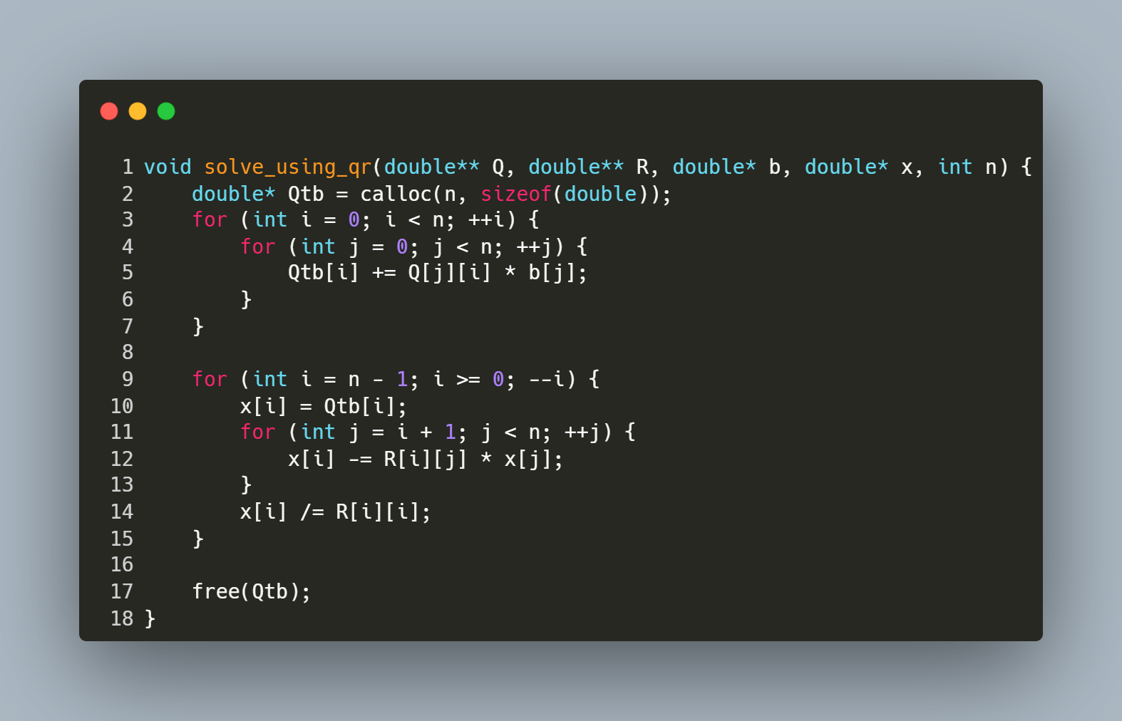
Step-by-Step Explanation
1. Compute Qᵀb
- Allocates a vector Qtb to store the product of Qᵀ (orthogonal matrix) and b.
- The nested loop calculates each element of Qtb as the dot product of the i-th column of Q (equivalent to the i-th row of Qᵀ) and b.
2. Backward Substitution
- Iterates backward from the last row (i = n-1) to the first (i = 0):
  - Initialize: x[i] = Qtb[i] (starting value for the solution element).
  - Subtract Known Terms: For each column j > i, subtract R[i][j] * x[j] to eliminate dependencies on already solved variables.
  - Normalize: Divide by the diagonal element R[i][i] to isolate x[i].

function : Reading Matrix and Vector Input from a File

Purpose: This function reads a square matrix A of size n x n and a vector b of size n from a file named "inputs.txt". It ensures proper error handling for file operations and input parsing.
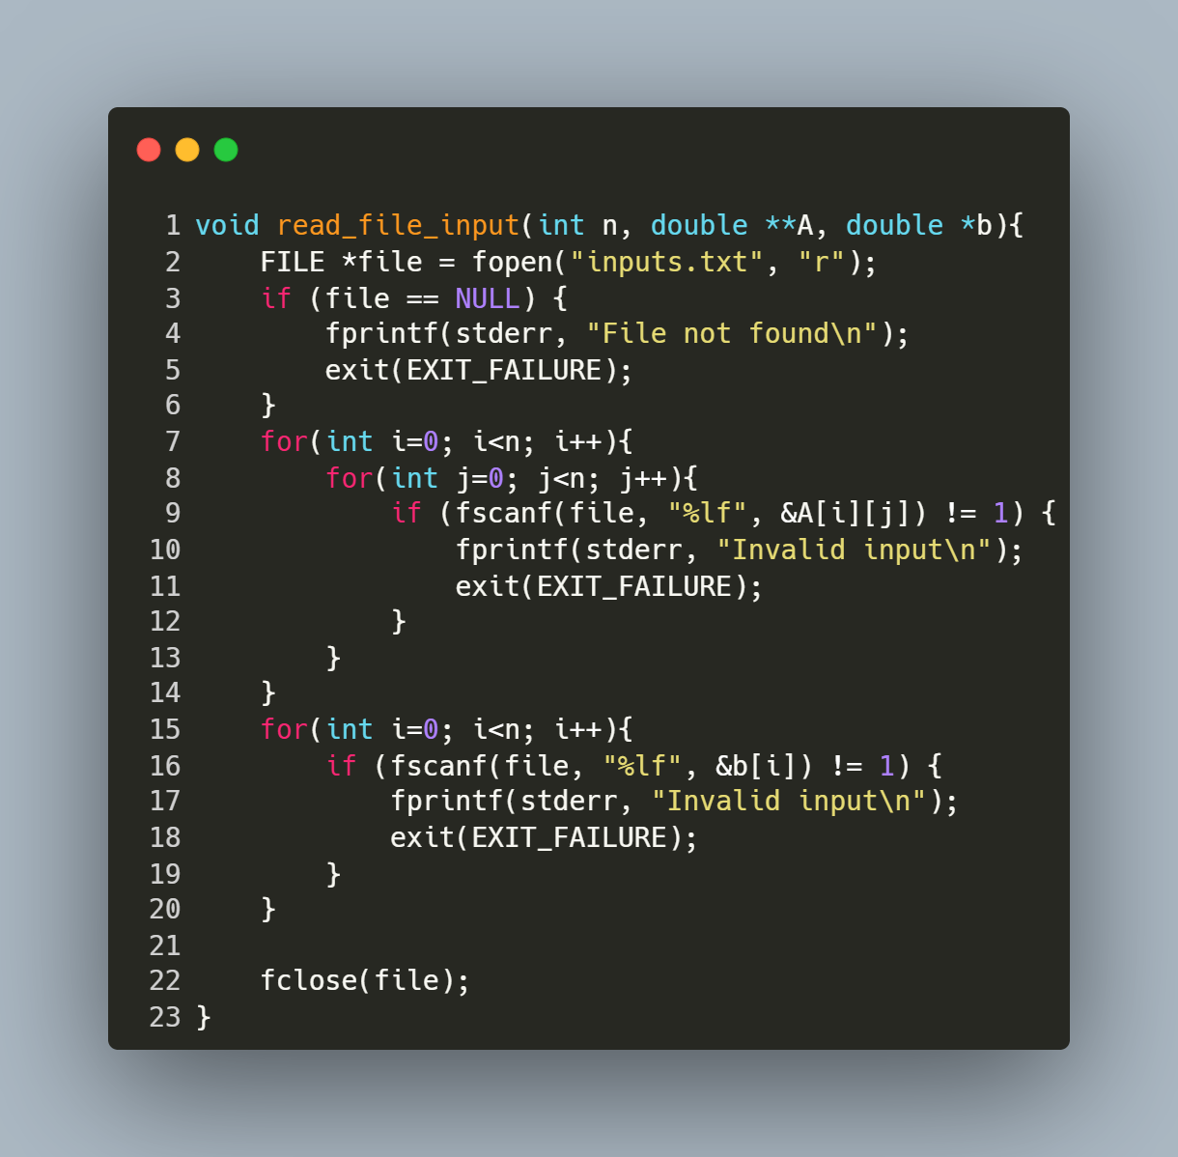
Step-by-Step Explanation
- Open File:
  - FILE *file = fopen("inputs.txt", "r"); opens the file "inputs.txt" in read mode.
  - If the file cannot be opened (e.g., it doesn't exist), the program prints an error message ("File not found") and exits.
- Read Matrix Elements:
  - The nested loop for (int i = 0; i < n; i++) { for (int j = 0; j < n; j++) { ... } } iterates through each row (i) and column (j) of matrix A.
  - fscanf(file, "%lf", &A[i][j]) reads a floating-point number from the file and stores it in the corresponding position in A.
  - If the input is invalid or missing, the program prints "Invalid input" and exits.
- Read Vector Elements:
  - The loop for (int i = 0; i < n; i++) { ... } iterates through each element of vector b.
  - fscanf(file, "%lf", &b[i]) reads a floating-point number from the file and stores it in the corresponding position in b.
  - Similar error handling ensures that invalid or missing input causes the program to terminate with an error message.
- Close File:
fclose(file); closes the file after all data has been read to release system resources.

Main Program for Solving Linear Systems via QR Factorization

Purpose: This program solves a linear system Ax = b using QR decomposition. It reads matrix A and vector b from a file, computes the orthogonal matrix Q and upper triangular matrix R, solves for x, and prints the solution, runtime, and matrix Q.
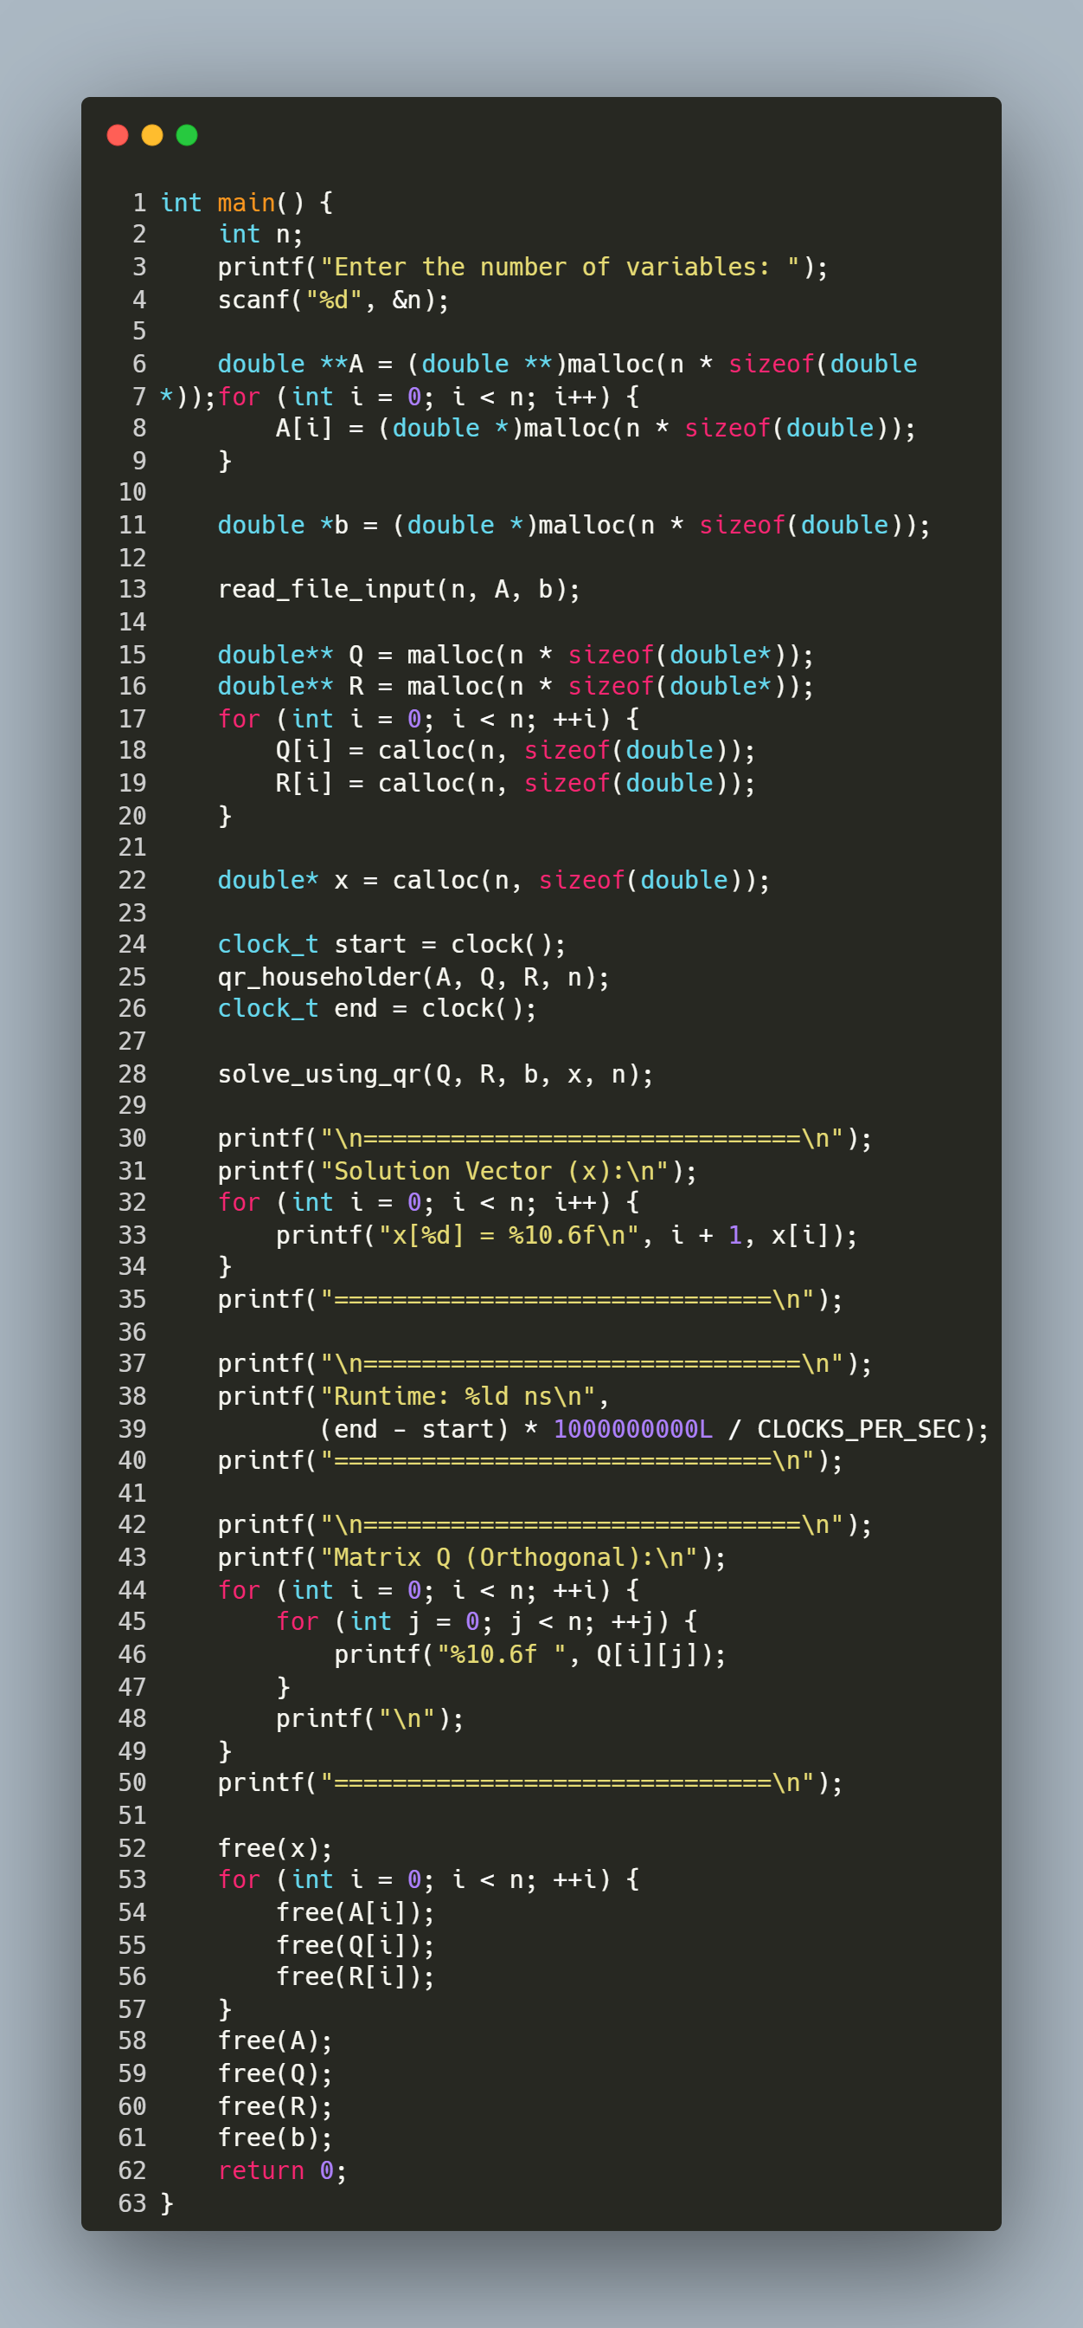
Step-by-Step Explanation
1. User Input
- Prompts the user to enter the number of variables (n).
2. Memory Allocation
- Allocates memory for:
  - A (n x n matrix) using nested malloc.
  - b (vector of size n).
  - Q and R (n x n matrices initialized with calloc).
  - x (solution vector initialized with calloc).
3. Read Input File
- Calls read_file_input(n, A, b) to populate A and b from "inputs.txt".
4. QR Factorization & Timing
- clock() records the start time.
- qr_householder(A, Q, R, n) decomposes A into Q (orthogonal) and R (upper triangular).
- clock() records the end time.
5. Solve for x
- solve_using_qr(Q, R, b, x, n) computes the solution vector x via backward substitution.
6. Print Results
- Displays the solution vector x with 6 decimal places.
- Prints the runtime in nanoseconds.
- Outputs the orthogonal matrix Q for verification.
7. Memory Cleanup
- Frees all dynamically allocated memory for A, b, Q, R, and x.

